Indian Emergency Response Portal(IERP)

Problem Statement

India is a country with very large population. So, it is very tedious to response by any system as quick as possible. But sometimes it is not possible to wait. Those situations are paramedics, police, fire . Over 1,10,000 people were killed in road accidents in 2016 alone, that is more than the number of people killed in world war I. Around 91,000 killings and many were looted. Over 2,75,000 constructions were burned. All because of unavailability of the respected departments of governments.

Problem Solution

After doing some research and analysis on the problem, we came with an idea of quick response system for paramedic, police, and fire related help and safety measures.

1.0 PROBLEM DEFINITION

This is a website and web application solution which gives quick response system for medical, police and fire related help. 1.1 The user can ask for nearest help for medical, police or fire station.

1.2The user can ask for the help if it is a registered user of the website. The IERP system authenticate the user and redirect its help signal to the respective department.

2.0 SYSTEM REQUIREMENT SPECIFICATION

2.1 INTRODUCTION

2.1.1 Purpose

2.1.1.1 The purpose of this SRS is to describe the requirements involved in developing a Emergency Response portal.

2.1.1.2 The intended audience is any person, who wants quick response of medical, police or fire department’s help.

2.1.2 Scope

2.1.2.1 The product is titled Indian Emergency Response Portal.

2.1.2.2 The product will perform the following tasks

2.1.2.2.1 Enquire for help by user.

2.1.2.2.2 Response signal generated by the respective departments on enquiry by user.

2.1.2.2.3 Response status of help signal.

2.1.3 Definitions, Acronyms and Abbreviations

2.1.3.1 DDBMS – Database Management System.

2.1.4 References

2.1.4.1 IEEE standard 830-1998 recommended practice for Software

Requirements Specifications-Description.

2.1.5 Overview

2.1.5.1 The SRS contains an analysis of the requirements necessary to help easy design.

2.1.5.2 The overall description provides interface requirements for the, Indian Emergency Response Portal system perspective, hardware interfaces, software interfaces, communication interface, memory constraints, product functions, user characteristics and other constraints.

2.1.5.3 Succeeding pages illustrate the characteristics of typical naïve users accessing the system along with legal and functional constraints enforced that affect Library Management System in any fashion.

2.2 THE OVERALL DESCRIPTION

2.2.1 Product perspective

2.2.1.1 Hardware interfaces

2.2.1.1.1 Hard disk: The database connectivity requires a hardware configuration that is on-line. This makes it necessary to have a fast database system running on high rpm hard disk permitting complete data redundancy and back-up systems to support the primary goal of reliability.

2.2.1.1.2 The system must interface with the standard output devise, keyboard and mouse to interact with this software.

2.2.1.2 Software interfaces

2.2.1.2.1 Back End: Mysql

2.2.1.2.2 Front End: Html, CSS, JS, Ajax.

2.2.1.3 Memory Constraints

2.2.1.3.1 No specific constraints on memory.

2.2.1.4 Operations

2.2.1.4.1 The software allows three modes of operations

2.2.1.4.1.1 Enquire of help signal by the user.

2.2.1.4.1.2 By extracting the username and password the website allows the user to ask for help by the departments.

2.2.1.4.1.3 By extracting the username and password the website allows the user to get the response by the system.

2.2.2 Product Functions

2.2.2.1.1 Enquire about the help by the user.

2.2.2.1.2 The system validates the authentic user by extracting their email address and password.

2.2.2.1.3 After the validation of the user to propose his/her help.

2.2.2.1.4 Single click on the required department icon for the help.

2.2.2.1.5 Single click on the sub icons of that department available to specify your problem.

2.2.2.1.6After the problem specification by the user, respective department initiate a response signal.

2.2.2.1.6The requested departments will track the processing of the response.

2.2.3 User characteristics

2.2.3.1 The intended users of this system need not have specific knowledge as to what is the internal operation of the system. Thus, the end user is at a high level of abstraction that allows easier, faster operation and reduces the knowledge requirement of end user

2.2.3.2 The website is absolutely user friendly, so the intended users can be the naïve users.

2.2.3.3 The product does not expect the user to possess any technical background. Any person who knows to use the mouse and the keyboard can successfully use this website.

2.2.4 Constraints

2.2.4.1 The user has a unique email address and website password, there is options to retrieve a password on the mail in case it is forgotten or lost.

2.2.5 Database Tables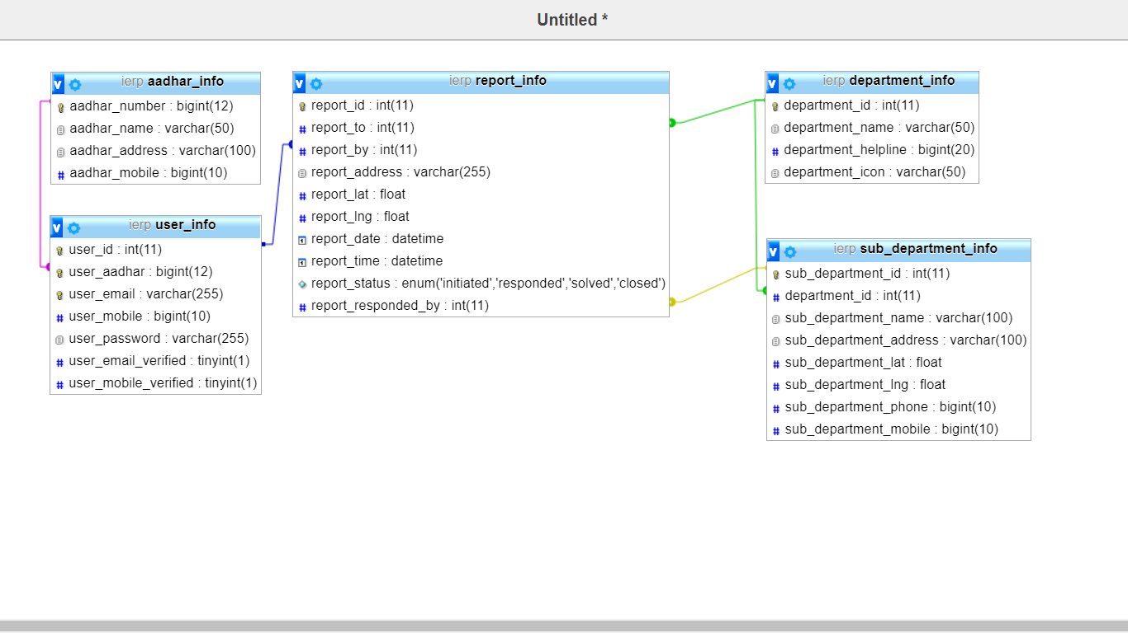

2.2.6 Data Flow Diagram

